11 HUMAN BIOLOGY

CELL STRUCTURE & METABOLISM

TOPIC TEST
SECTION A: (30 marks)

1. The number of chromosomes in the somatic cells of humans is:

(a) 23
(b) 24
(c) 46
(d) 48

2. The two strands of a chromosome which are joined together during the early phases of mitosis are called:

(a) kinetochromes
(b) chromatids
(c) spindle fibres
(d) centrosomes

3. A benign tumour

(a) is always harmless
(b) is one which is dormant
(c) does not invade surrounding tissues
(d) can give rise to secondary tumours

4. The primary function of ribosomes in the cell is:

(a) removal of waste products
(b) storage of glycogen
(c) synthesis of mucopolysaccharides
(d) synthesis of polypeptide chains

5. When looking through the microscope the same organisms under different magnification would seem to move at different speeds because the area observed under high power:

(a) is larger than under low power
(b) is the same as the area seen under low power but magnification is greater
(c) is smaller than under low power
(d) would contain fewer organisms

6.
Mitochondria concentration would be highest in which of these cells?

(a) Nerve cells.
(b) Secretory cells.
(c) Muscle cells.
(d) Red blood cells

7. The blue-print for protein-synthesis is carried to the site of synthesis by:

(a) DNA
(b) ATP
(c) Transfer - RNA
(d) Messenger - RNA

8. In this diagram of a chromosome from a cell in late prophase, to what structure is the arrow pointing?

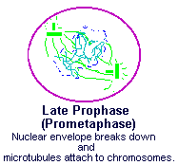

(a) Centriole
(b) Chromatid
(c) Spindle
(d) Centromere

9. Phosphate-sugar-base complexes that are the basic building blocks for nucleic acids are called:

(a) nucleoproteins
(b) base triplets
(c) amino acids
(d) nucleotides

10. There is considerable evidence that the genetic code of a DNA molecule
consists of triplets of the nitrogenous bases adenine, guanine, cytosine, and thiamine. For convenience, these are usually represented by the letter A,G,C, and T respectively.

The current hypothesis is that each different triplet of bases -AGC, GAC, TGT, CAT, etc. -

(a) corresponds to a different characteristic of the organism
(b) controls a different organelle in the cell
(c) controls the activity of a different enzyme
(d) predetermines the position of an amino acid unit in a protein

11 Animal cells contain organelles. The organelle essential for normal cell division is:

(a) the mitochondrion
(b) the nucleus
(c) the cell membrane
(d) the Golgi body

12. Which of the following bases are paired in a DNA molecule?

(a) Cytosine and Thiamine
(b) Cytosine and Adenine
(c) Cytosine and Valine
(d) Cytosine and Guanine

13. The body can be sequentially divided into units of decreasing size. From the largest to the smallest units, the correct sequence is:

(a) cells, organelles, tissues, organs, systems
(b) systems, organs, tissues, cells, organelles
(c) cells, tissues, organelles, organs, systems
(d) systems, organs, organelles, tissues, cells

14. Which of the following statements about malignant cancers is CORRECT?

(a) Malignant cancers tend to spread to parts of the body distant from the tissue in which they originate.
(b) Malignant cancers can only be treated by radiotherapy.
(c) All forms of malignant cancers are more common in males than in females.
(d) Diagnosis of malignant cancer is difficult because most cancerous cells appear very similar to normal cells.

15. Four microscopes were set up in the laboratory as follows:

Microscope Objective Ocular
A 10X 5X
B 20X 10X
C 40X 5X
D 40X 10X

When looking at a slide of human tissue, with which microscope would you expect to observe the fewest cells?

(a) A
(b) B
(c) C
(d) D

16. The type of tissue lining the digestive tract is:

(a) epithelial tissue
(b) connective tissue
(c) muscular tissue
(d) contractile tissue

17. In connective tissues, the matrix may exist as a fluid, semifluid, or, gelatinous material. In circulating tissue the matrix forms the:

(a) blood
(b) lymph
(c) plasma
(d) corpuscles

18. An organ can be best defined as:

(a) structure which is composed of epithelium and muscle.
(b) a structure composed of connective tissue, epithelium and nervous tissue.
(c) a group of tissues which function together in the performance of some vital activity.
(d) a group of connective and epithelial tissues only which function together in the performance of some vital activity.

19. The four major groups of tissues are:

(a) bone, muscle, nerve, epithelial
(b) muscle, cartilage, bone, nerve
(c) skin, bone, nerve, muscle
(d) epithelial, connective, muscle, nerve44ó

20. If the lining of the cheek is gently scraped with a blunt scalpel and the scrapings examined under a microscope, it is possible to see:

(a) salivary juice
(b) cells showing nuclei
(c) cells lacking nuclei
(d) enzymes

21. A series of inter connecting canals transporting fluids has been observed in the cell. These canals are called:

(a) mitochondria
(b) endoplasmic reticulum
(c) centrioles
(d) lysosomes

22. The process of cellular respiration occurs in organelles called:

(a) Golgi bodies
(b) grana
(c) ribosomes
(d) mitochondria

23. The organelles responsible for secretion from a cell are called the:

(a) nucleolus
(b) Golgi bodies
(c) ribosomes
(d) endoplasmic reticulum

24. Growth and repair of body tissues depends especially on the uptake of;

(a) carbohydrates
(b) glucose
(c) fats
(d) proteins

25. Cristae are found in the:

(a) mitochondria
(b) ribosomes
(c) vacuoles
(d) endoplasmic reticulum

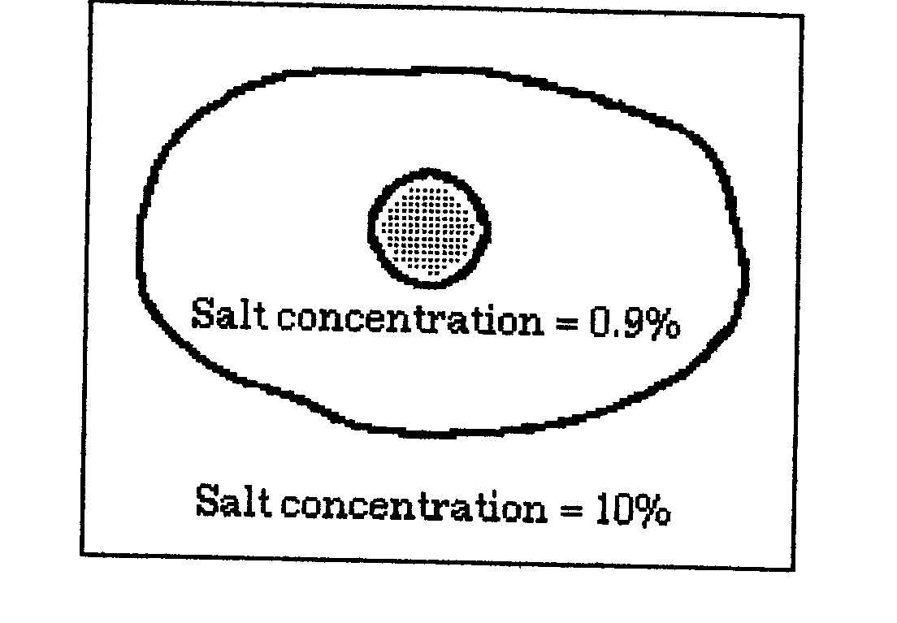
26. .

The cell in the above diagram would probably:

(a) expand and burst open.
(b) shrivel up.
(c) retain its normal shape.
(d) lose its salt content.

27. Which of the following are necessary for protein synthesis?

(a) Amino acids, DNA, ADP, phosphate
(b) Amino acids, ATP, phosphate, energy
(c) Amino acids, DNA, enzyme, energy
(d) Amino acids, ADP, enzyme, phosphate

28. In vigorous exercise (when the muscles are unable to receive sufficient oxygen), glucose is changed into which one of the following to produce energy?

(a) Lactic acid
(b) Amino acid
(c) Ethyl alcohol
(d) Glycogen

29. Which of the following does NOT cause cancer:

(a) Bacteria
(b) Viruses
(c) Radiation
(d) Chemicals

30. A.T.P. is essential to every living cell because it:

(a) reacts with energy from glucose to form A.D.P.
(b) speeds up digestion of carbohydrates
(c) stores energy in a form that is instantly available
(d) stores energy released during the breakdown of A.D.P.

Written Section
1. Define the term tissue? (1 mark)

2. (a) what is cellular synthesis?

(b) Provide an example. (2 marks)

3. Describe how energy is released from ATP? (1 mark)

4. How do you distinguish between the three types of muscle tissue
in terms of their appearance and their function. (3 marks)

5. What is metastasis? (1 mark)

6. What is meant by the terms benign and malignant as applied
to tumours. (2 marks)

7. Label the generalised cell and the many organelles and structures
as possible.
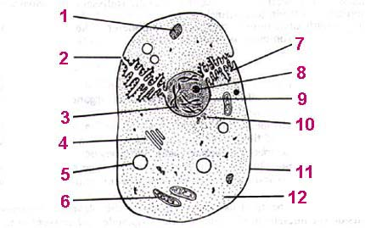

(12 marks)

8. What are the tissues and where would they be found. ( 6 marks)

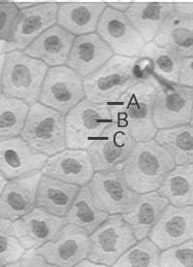 b) 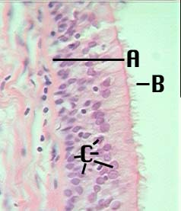 c) 